**HOSTING JUICE-SHOP WEBSITE THROUGH DOCKER**

**Installing Docker: apt-get install docker**

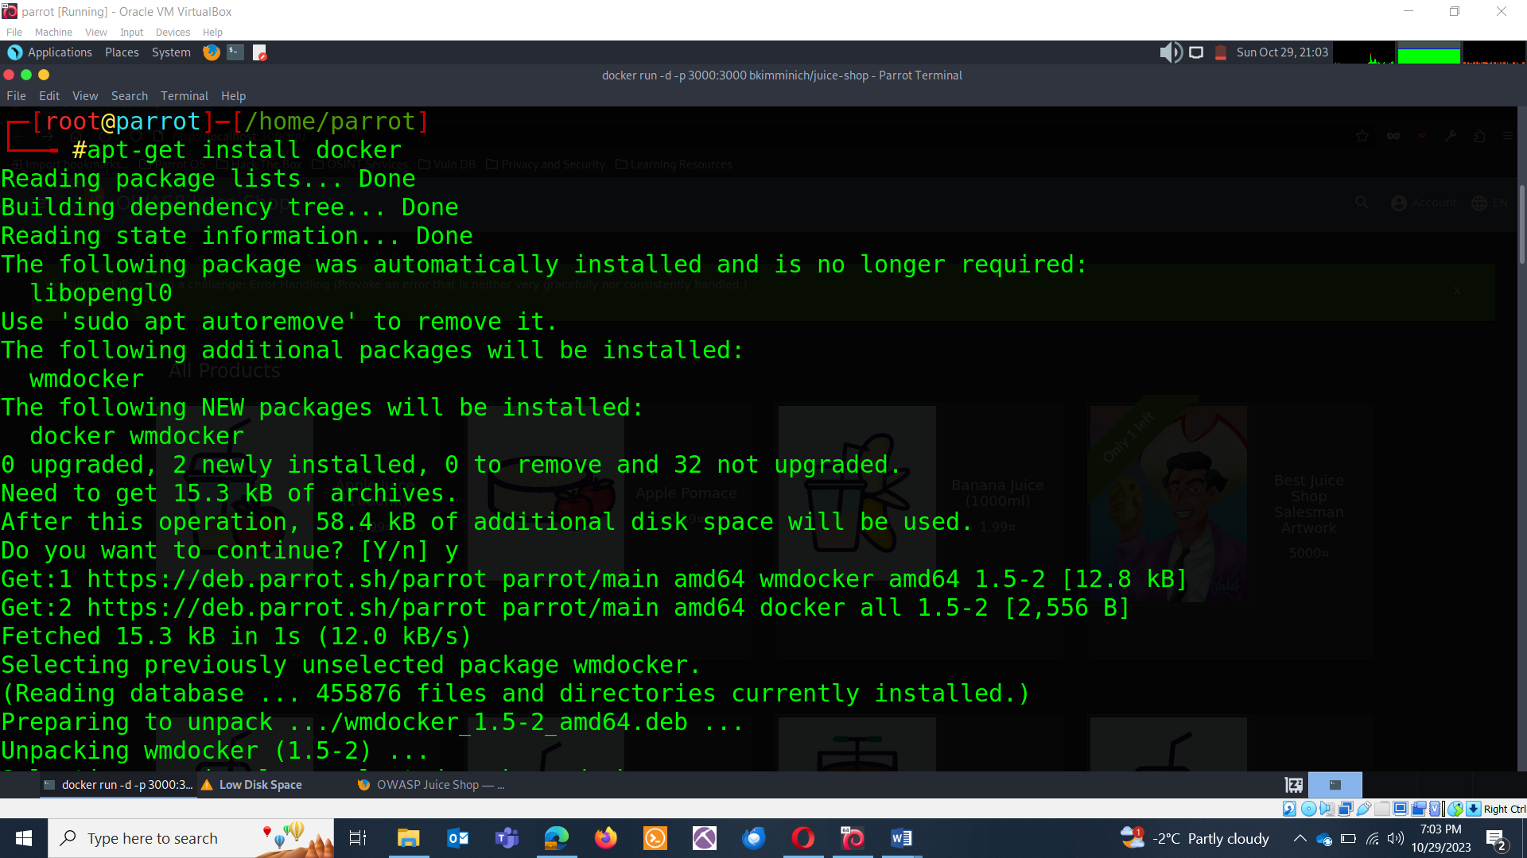

**Pull the Juice Shop Docker Image:** You can use the official Juice Shop Docker image from the OWASP project on Docker Hub. Open your terminal and run the following command to pull the image:

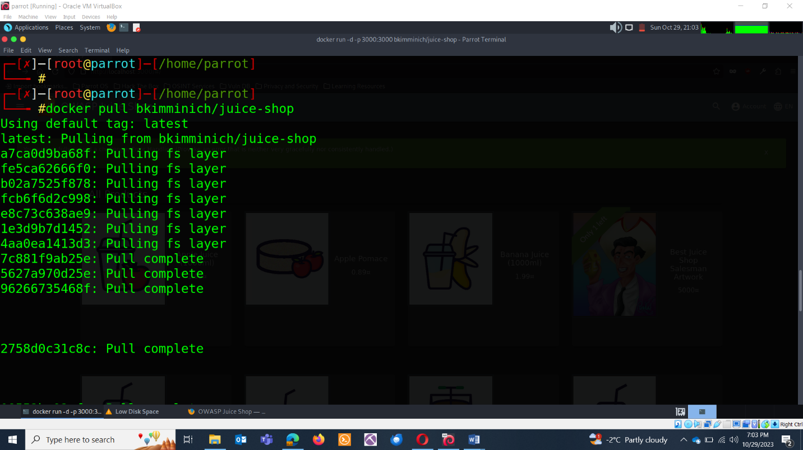

**Run the Juice Shop Container:** Once the image is pulled, you can start a container using the following command:

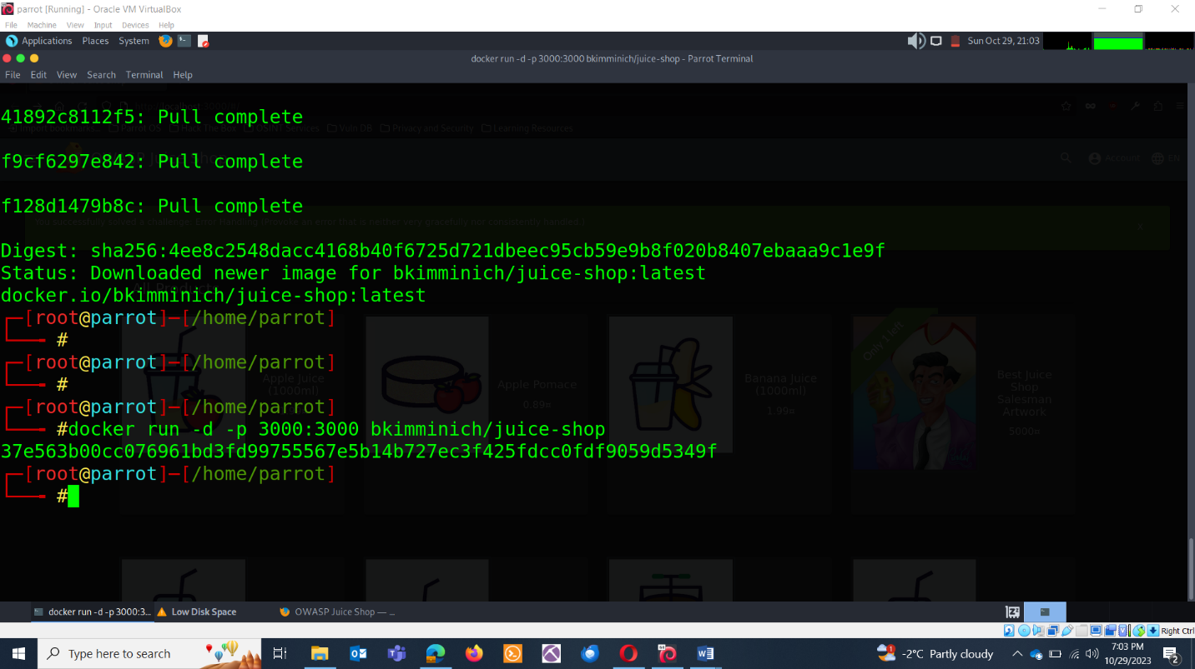

**Access the website**: http://localhost:3000

